Required Capstone Checkpoint 5.1: Designing and Evaluating an Agent-Based RAG System

Directions
Download this worksheet and save a copy to your device before you begin working. Use this worksheet to plan, organize, and complete your submission for Required Capstone Checkpoint 5.1. Type your responses directly into the document, save your completed work, and upload the finished file when you are ready to submit.

Completion Checklist
☒ Description of the agent-based system and task
☒ Explanation of how the system coordinates retrieval, reasoning, and multistep execution
☒ Evaluation results from 2-3 representative multistep test cases
☒ Description of refinements made to the system
☒ Analysis of the impact of those refinements
☒ Reflection on system strengths, limitations, and future improvements

Step 1. System Design
Describe the task that your agent-based system is designed to complete.
Examples may include generating reports, answering complex questions, synthesizing information across multiple documents, or completing another multistep task relevant to your capstone scenario.
Task description
The agent-based system is designed for multi-step research, topic-specific filtering, and interactive question answering over a wiki-files corpus. Unlike fixed retrieval pipelines that execute query as single-pass search, this agent is placed fully in charge of the conversation flow. It dynamically plans actions step-by-step choosing between hybrid retrieval (retrieve), topic-based filtering, user clarification (clarify), and final answer synthesis (answer). Its primary goal is to resolve complex or multi-part enterprise queries accurately while restricting answers strictly to retrieved source context without speculation

Agent workflow: Describe how your system works
Retrieval Approach:
Retrieval is incorporated into a state (LangGraph StateGraph) via two tool nodes: retrieve_node and retrieve_by_topic_node. retrieve_node invokes HybridRetriever, combining BM25 keyword scoring with Chroma vector similarity (openai/text-embedding-3-small) to pull candidate wiki-files. retrieve_by_topic_node executes based on matching file name as topic to return all wiki-files for the topic (max. 70 files)
Reasoning & Processing:
Intermediate reasoning occurs inside plan_node using the openai/gpt-oss-120b LLM with system prompt PLAN_SYSTEM. On each step, plan_node analyzes the conversation history, executed queries list, retrieved wiki-file bodies, and prior clarifications to output a strict JSON decision object containing action, queries, file_name, clarification, and reasoning.
Multistep Behaviors:
Execution routes dynamically via route_from_plan. When plan_node outputs retrieve or by_topic, the tool node fetches context, updates _AgentState (appending document bodies and marking executed queries), and loops back to plan_node for re-evaluation. If the user's intent is ambiguous, execution routes to clarify_node to obtain user input before re-planning. To prevent infinite loops, MAX_ITERATIONS forces a fallback transition to answer_node.
Prompts & Tools Used:
Prompts PLAN_SYSTEM Enforces strict JSON output specifying action choice (retrieve, by_topic, clarify, or answer), sub-queries, or clarification text.
ANSWER_SYSTEM: Instructs the model to synthesize answers exclusively from retrieved wiki-files and strictly handle exit requests
Tools retrieve: Multi-query semantic hybrid search.
- retrieve_by_topic: Exact document retriever.
- clarify: Conversational prompt requesting user clarification
- answer: Final response generation node

Step 2. Initial Evaluation
Develop and evaluate your system using 2-3 representative test cases for your capstone scenario. Each test case should require more than one retrieval step or action.
For each test case, compare the agent-based system with your fixed retrieval pipeline from Checkpoint 2.1 or 3.1. Record relevant differences in answer quality, completeness, retrieval behavior, model calls, latency, or cost.
Evaluation results
Query | Initial System | Refined System
What is Apollo 11? | Executes hybrid retrieval for k=5 seed files and walks NetworkX topic edges may miss files on the topic if topic edge degree exceeds TOPIC_EARLIEST=5 | plan_node selects action: "by_topic" with file_name: "Apollo_11". retrieve_by_topic_node retrieves all matching wiki-files on that topic (up to MAX_TOPIC_COUNT=70)
Tell me about the project? | Immediately executes hybrid vector/BM25 search on "project", returning “The provided articles do not contain information…” | plan_node detects missing query specificity, outputs action: "clarify", and prompts the user for clarification before executing retrieval
what was Apollo 11? who approved it? and when was it launched? | Executes a single pass of multi-step query decomposition and graph expansion. If initial sub-queries miss celebration details, it cannot issue follow-up searches | plan_node outputs action: "retrieve" with sub-queries ["what was Apollo 11", " who approved it ", "when was it launched? "]. After inspecting initial results in _AgentState, it can issue follow-up queries or proceed to answer_node

Strengths observed
- The LLM planner adapts retrieval strategies based on query type (semantic search vs. topic lookup).
- clarify_node prevents wasted retriever and LLM operations on ambiguous user messages.
- _AgentState tracks executed_queries to avoid duplicate retrieval requests across planning iterations

Weaknesses or challenges identified
retrieve_by_topic matches exact .txt filenames in the target folder, requiring the planner to output accurate file identifiers

Step 3. System Refinement
Based on your evaluation results, make one or more improvements to your system. Examples may include:
- Improving system prompts
- Adjusting workflow structure
- Modifying retrieval behavior
- Improving how the agent uses retrieved information
Changes implemented
Multi-Action State Machine: Transitioned from single-action retrieval ("retrieve more") to a 4-action LangGraph workflow (retrieve, by_topic, clarify, answer) to handle distinct query intents.
Dedicated Topic Lookup Node: Integrated retrieve_by_topic_node to bypass vector search noise when a user asks for complete coverage on a specific topic.
Structured Planner Schema (PLAN_SYSTEM): Implemented a strict JSON schema for plan_node forcing the agent to log reasoning, select discrete actions, and pass explicit parameters (queries, file_name, clarification).
Safety & Loop Guards: Added MAX_ITERATIONS (5) to force transition to answer_node if planning loops persist, preventing infinite execution.

Justification
The initial design could only iterate semantic queries. The refined architecture (tool, agent based) intelligently routes between semantic search, direct topic matching, user interaction, and answer synthesis based on state history.

Step 4. Impact of Refinement
Evaluate the updated system. Describe any changes in task completion, accuracy, relevance, or overall system behavior. Compare the refined agent-based system with both its initial version and the fixed baseline. Explain whether the refinement improved performance and identify any trade-offs.

Impact on system performance
Topic-Specific Precision: Introducing action: "by_topic" via retrieve_by_topic_node allows the agent to fetch 100% of wiki-files matching a target topic name (up to MAX_TOPIC_COUNT = 70). This completely eliminates topic chunk truncation and vector ranking misses present in vector-only search.
Multi-Turn Completeness: The iterative loop (MAX_ITERATIONS = 5) enables plan_node to issue 1–3 distinct sub-queries (pending_queries) per turn, accumulate retrieved documents in wikifile_bodies, and synthesize answers over complete context.
Reduced Noise & Hallucination: On underspecified prompts, routing to clarify_node collects missing user intent before executing database searches, preventing irrelevance and hallucinated responses.
Query Deduplication: _AgentState records all executed_queries across iterations. PLAN_SYSTEM explicitly instructs the model not to repeat executed queries, keeping the retrieved document state compact and avoiding duplicate token overhead

Comparison of initial and refined systems
Initial System | Refined System
Executes a single-pass hybrid vector/BM25 search followed by fixed NetworkX graph traversal | Uses StateGraph with a central plan_node dynamically routing to 4 actions (retrieve, by_topic, clarify, answer).
Fetches seed chunks and walks relates_to topic edges unconditionally on every query. | Combines hybrid semantic search (retrieve) with direct topic document fetching (by_topic)
Evaluates input statically. Cannot ask clarifying questions or modify search strategy dynamically. | Uses _AgentState to log executed_queries, wikifile_bodies, clarification_history, and enforces MAX_ITERATIONS = 5

Step 5. Reflection
Reflect on your experience designing and evaluating an agent-based RAG system.
What contributed most to successful task completion?
Orchestrating agent flow using LangGraph state tracking. Combining semantic hybrid retrieval (HybridRetriever) with direct topic matching (by_topic) and interactive clarification (clarify) enabled flexible handling of diverse user queries.

What limitations remain?
1. JSON action parsing relies on raw string manipulation and fallback logic. This terminates the retrieval loop prematurely before the agent has gathered sufficient context
2. Topic matching relies on filename string references rather than an explicit metadata index

What improvements would you prioritize next?
Topic is relying on file name, rather it can be LLM based identification. While generating the vector database and reading the files, we can use the LLM to name this topic and store it.

Supporting Materials
Use this section to list, describe, or link to any supporting materials included with your submission.
Supporting material | Location, link, or note
System prompts: | ANSWER_SYSTEM = """You are a helpful assistant for Wiki Files \  Answer questions exclusively from the company wiki-files provided as context. Consider \  any clarifications, which may add important details; if the original message is not a \  full question, answer the last question asked in the clarifications. If the retrieved \  wiki-files do not contain enough information, say so explicitly. Do not speculate or use \  outside knowledge. If the user is simply asking to exit, answer exactly: Exiting"""  PLAN_SYSTEM = """You are a research agent for Wiki Files. You help the user \  find information about the company using a semantic search database of company wiki-files.  You are given the user's question (and prior conversation), the queries already executed,  the wiki-files retrieved so far, and any clarifications from the user. Decide what to do next  and respond with a JSON object ONLY:  {  "action": "retrieve" | "by_topic" | "clarify" | "answer",  "queries": ["query1", "query2"], // 1-3 NEW queries; only for action=="retrieve"; don't repeat executed ones  "file_name": "name of file related with topic", // only for action=="by_topic"  "clarification": "question text", // only for action=="clarify"  "reasoning": "brief explanation"  }  Guidelines:  - "retrieve": you need more information via semantic search.  - "by_topic": the question references specific topic ("Apollo 11", "Election 2024"). Retrieves ALL wiki-files on that topic (<= 70).  - "clarify": the message isn't really a question and you must ask for more input. Use ONLY  as a last resort, and only AFTER attempting to query the database.  - "answer": you have enough information, or the user asked to exit.  Products are sometimes referred to by multiple names — searching alternate names can help."""
Evaluation results: | You: What is Apollo 11?  -> [agent] action=by_topic reasoning='The user asks about a specific topic, Apollo 11, so the best next step is to retrieve all wiki-files related to that topic.'  [agent] by_topic Apollo 11: 0 wiki-file(s)  [agent] action=by_topic reasoning='The user asked about a specific topic, Apollo 11. The appropriate next step is to retrieve all wiki-files related to that topic.'  [agent] by_topic Apollo 11: 0 wiki-file(s)  [agent] action=answer reasoning='The user asked a generic factual question about Apollo 11, but in this workflow I only have access to the company wiki-files search results. Since no wiki-files were retrieved and the topic query already returned nothing, there is nothing from the wiki database to answer with.'  Assistant: I don’t have enough information from the retrieved wiki-files to answer what Apollo 11 is.  You: how long the celebration lasted?  [agent] action=by_topic reasoning='The user is asking about a specific topic, Apollo 11. Retrieving all wiki-files on that topic is the most direct next step.'  [agent] by_topic Apollo 11: 0 wiki-file(s)  [agent] action=by_topic reasoning='The user is asking about a specific topic, Apollo 11. Retrieving all wiki-files for this topic is the most direct next step, since the topic search returned no files and the follow-up depends on topic-specific information.'  [agent] by_topic Apollo 11: 0 wiki-file(s)  [agent] action=by_topic reasoning='The user is asking about a specific topic already identified as Apollo 11. To answer follow-up questions like the duration of the celebration, I should retrieve all wiki-files on that topic.'  [agent] by_topic Apollo 11: 0 wiki-file(s)  [agent] action=by_topic reasoning='The user is asking a follow-up about Apollo 11, which is a specific topic. Retrieving all wiki-files for that topic is the best next step.'  [agent] by_topic Apollo 11: 0 wiki-file(s)  [agent] action=by_topic reasoning='The user is asking about a specific topic, Apollo 11, and the prior search returned no files. Using the topic-based retrieval should gather all relevant wiki-files for Apollo 11, including any file that may mention the celebration length.'  [agent] by_topic Apollo 11: 0 wiki-file(s)  [agent] max iterations — forcing answer.  Assistant: I don’t have enough information from the retrieved wiki-files to answer how long the celebration lasted  You: Tell me about the project?  [agent] action=retrieve reasoning='The question is broad and refers to a project without a specific name, so I should search for general project-related wiki files to identify the relevant one before answering.'  [agent] retrieving for: 'project overview'  [agent] retrieving for: 'company projects'  [agent] retrieving for: 'active project status'  [agent] action=answer reasoning="The retrieved files are about Apollo 11, not a company project. To answer the user's question about 'the project,' I need the actual company project-related wiki-files or a clearer project name."  Assistant: Project Apollo was NASA’s program to land humans on the Moon and return them safely to Earth. It grew out of the Space Race after Sputnik and was formally driven by President Kennedy’s 1961 goal to achieve a Moon landing before the end of the 1960s.  From the wiki files, key points about the project are:  - It used the Apollo spacecraft, made up of:  - a command module to carry the astronauts and return to Earth,  - a service module for propulsion, power, oxygen, and water,  - a lunar module for landing on the Moon and returning the astronauts to lunar orbit.  - NASA chose lunar orbit rendezvous as the mission architecture.  - The project depended on technologies developed in Mercury and Gemini, including advances in semiconductor devices and the Apollo Guidance Computer.  - It suffered a major setback with the Apollo 1 fire in 1967.  - Apollo 11 was the mission that completed the goal, landing Armstrong and Aldrin on the Moon in July 1969.  If you want, I can also summarize the project as a timeline or explain its main technical decisions.
Screenshots or diagrams: | 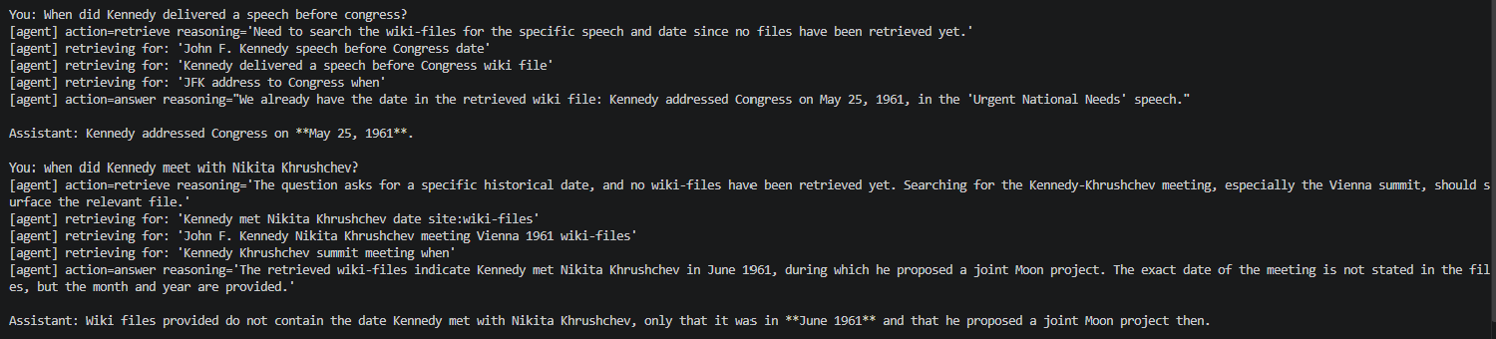  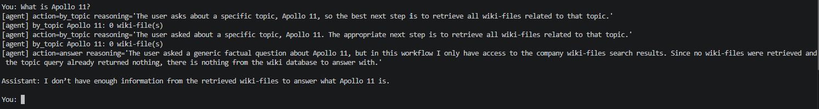  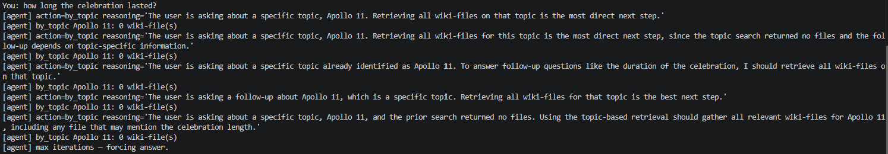  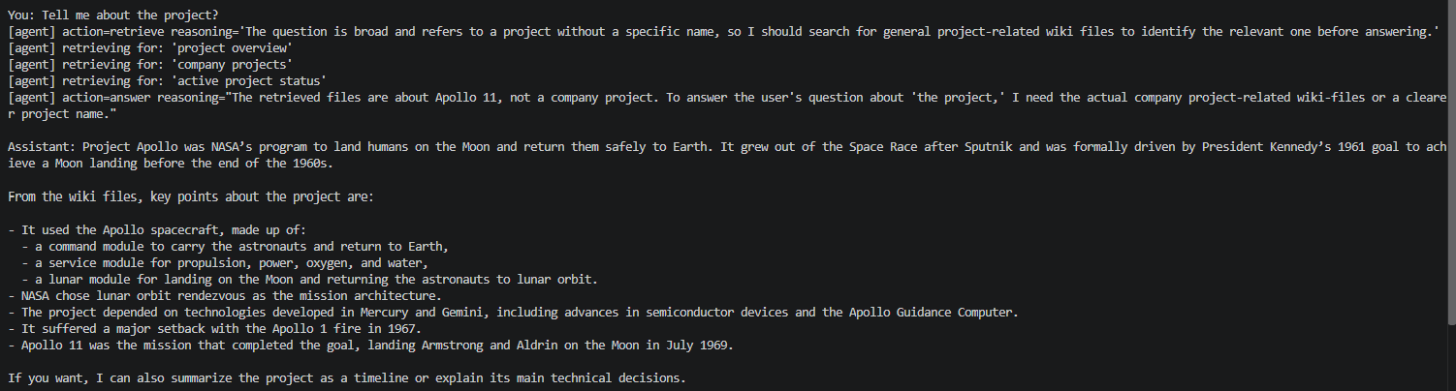
Code, notebook, or repository link: | https://github.com/merasupermarket/RAG-WITH-MIT-XPRO
Other supporting evidence: | Created the chunks based on each paragraph and generated the multiple txt files from Wikipedia article- https://en.wikipedia.org/wiki/Apollo_11

End of Required Capstone Checkpoint 5.1
Return to the assignment page in the learning platform to upload and submit your completed capstone checkpoint worksheet and complete any remaining items in this module.

